Christophe Denoux
크리스토프 더누
Mosaïste – Vitrailliste
모자이크-스테인드 글라스

모자이크-스테인드글라스 제작,설치 전문가

프랑스의 아티스트,Christophe Denoux(크리스토프 더누)는 20여년동안,줄곧 그의 두손과 하늘이 주신 예술적 재능으로 정교하고 완벽한 세상에 둘도 없는 예술적 작품들을 창조하였습니다. 그는 그의 작품을 반복하지 않으므로서,고객들은 그의 예술적 가치를 인정하였으며 ,자신들이 바라는 완벽한 경지를 만족시켰습니다. 예: 사우디아 전 국왕/ 카타르의 추장/ 바레인 국왕 등등...
크리스토프 더누의 독특한 예술작품 스타일은 전통적이며 자연적인 소재를 사용 하는것입니다.그는 자기만의 독특한 기술로 유약을 바르지 않은 타일과유리 모자이크를 혼합하여 과거, 현재, 미래, 세가지 부동한 공간에서 함께 존재하는 작품들을 창조하여, 채색유리공예에서 그의 작품은 그만의 전통적인 모자이크 기술과 빛 둘사이의 독특한 미감을 집중시킨 원시적인 아름다움을 보여줍니다. 그는 그의 예술작품이 전체 설계와 어울리게 하기 위해서 사적인 고객들의 요구에 따라 실내디자이너,건축가들과 작업합니다.

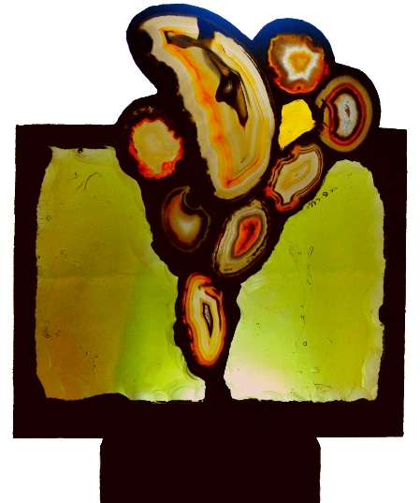 | 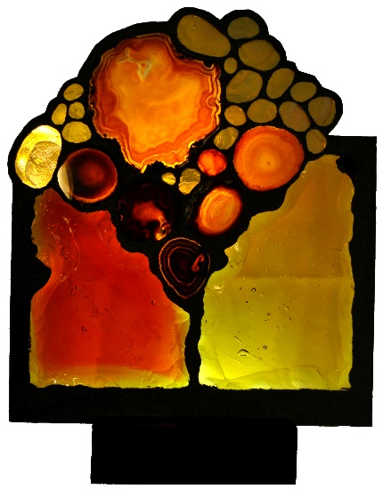
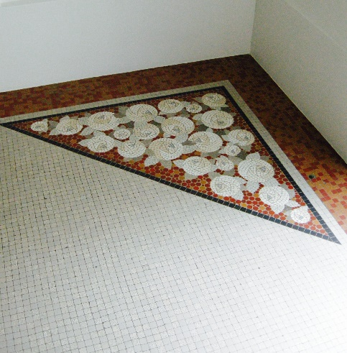 | 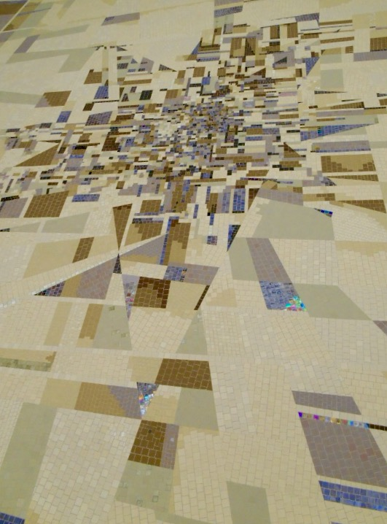

크리스토프 더누의 작품 주요 제작은 공공장소, 카페 혹은 부띠끄에서 완성 설치하였습니다.
Educator | Professor assistant of Atelier Pierre Soulages - Charenton le Pont | 2009 - 2014
Heritage restoration | Les Deux Magots - 6, place Saint Germain des Prés - Paris VI° | 2004 - 2010
Educator | Mosaic teaching at the workshop | 2000 - 2014
Private Collection | Think Pink – Breast Cancer fundraising - Hong Kong | 2015
Public work | Passerelle Odorico - 35000 Rennes | 2014
Private collection | Floor of the hall - 46, rue de Bourgogne - Paris VII° | 2014
Heritage restoration | Floor of the hall - 29, rue de Liege - Paris VIII° | 2014
Heritage restoration | Pool of villa - 95160 Montmorency | 2013
Private Collection | Signboard FRED'S - 06000 Nice | 2012
Public work | Fountain - Ambassy of Iran - Paris | 2012
Private Collection | Floor of the hall - rue Elysee Reclus - Paris VII° | 2012
Heritage restoration | Floor of the hall - 6, rue Gustave Doré - Paris XVII° | 2012
Heritage restoration | Floor of the hall - 11, rue François Millet - Paris XVI° | 2012
Heritage restoration | Floor of the hall -29, rue de Berne - Paris VIII° | 2011
Heritage restoration | Floor of the hall - 306, rue de Vaugirard - Paris XV° | 2011
Public work | Floor "Au Zaganin" - 81, rue de Rochechouart - Paris IX° | 2010
Heritage restoration | Floor of the hall - 9bis, rue Boileau - Paris XVI° | 2010
Heritage restoration | Floor of the hall - 35, rue du Pré-Saint-Gervais - Paris XIX° | 2010
Heritage restoration | Floor of the hall - 112, quai de Jemmapes - Paris X° | 2010
Heritage restoration | Guerlain 68, avenue des Champs Elysée -Paris VIII° | 2010
Public work | Signboard "Café M "- 1, rue de Maubeuge - Paris IX° | 2009
Heritage restoration | Floor of the hall - 5, rue des Feuillantines - Paris V° | 2009
Heritage restoration | Floor of the hall - 5, rue des Marronniers - Esbli | 2009
Heritage restoration | Floor of the hall - 28, avenue du Président Kennedy - Paris XVI° | 2009
Heritage restoration | Floor of the hall - 83, rue de Longchamp Paris XVI | 2009
Show and salon | Salon SMAC | 2009
Private Collection | The bathroom friezes - 3 rue de Miromesnil - Paris VIII | 2008
Private Collection | Signboard: Mr. J | 2008
Private Collection | Floor of the hall - 29, rue du Général Delestraint - Paris XVI° | 2008
Show and salon | Salon SMAC | 2008
Show and salon | Salon CULTURA | 2008
Show and salon | Salon CREATUS | 2008
Private Collection | Floor - Madame M | 2007
Public work | Floor of the hall - "Le Mistral" - 2, Place du Chatelet - Paris IV° | 2007
Heritage restoration | Floor of the hall - 14, rue du Val de Grace | 2007
Heritage restoration | Floor of the hall - 31, rue Godot de Mauroy - Paris IX° | 2007
Show and salon | Salon SMAC | 2007
Show and salon | Salon CULTURA | 2007
Private Collection | Fresco with nasturtiums - Madame M | 2006
Private Collection | The bathroom friezes- Cote d'Azur | 2006
Private Collection | The bathroom friezes - Paris XVI | 2006
Public work | Logos –Li10 | 2006
Heritage restoration | Villa - 95160 Montmorency | 2006
Show and salon | Salon SMAC | 2006
Private Collection | Fresco with Iris - Madame M | 2005
Public work | Floor of "L'Etoile Manquante' - 32, rue Vieille du Temple - Paris IV° | 2005
Show and salon | Salon SMAC | 2005
Private Collection | Floor Garden - Madame M | 2004
Private Collection | Angel Mosaic - France | 2004
Public work | Floor of "La Belle Hortense" - 31, rue Vieille du Temple - Paris IV° | 2004
Public work | Floor of "La Chaise au Plafond" - 10, rue du Trésor – Paris IV° | 2004
Heritage restoration | Floor of the hall - 30, avenue d'Eyleau - Paris XVI° | 2004
Heritage restoration | Floor of the hall - 73, rue Lamarck - Paris XVIII° | 2004
Heritage restoration | Villa - 92400 Courbevoie | 2004
Show and salon | Salon SMAC | 2004
Public work | Floor "Les Philosophes" - 28, rue Vieille du Temple - Paris IV° | 2003
Public work | Logo Bonbon Watch Paris - Tokyo | 2003
Public work | Floor "Le Petit Fer à Cheval" -30, rue Vieille du Temple - Paris IV° | 2002
Public work | Floor "Les Deux Magots "- 6, place Saint Germain des Prés - Paris VI° | 1993
Public work | Floor of the dining room of Hotel Bel Air Cap Ferrat - France | 1992

Books :
Cafés d’artistes à Paris… Hier et aujourd’hui
Brasseries de Paris
Restaurants brasseries et bistrots Parisiens

Christophe Dénoux’s Bio

Mosaïste - Vitrailliste
Mosaic – Stained Glass Master

For more than 25 years, the French artist Christophe Dénoux has put his talent in creating the artworks for the most demanding clients in the world, and most of his artwork is commissioned by private collectors.
With his unique ability to pursue perfection, each piece of Dénoux’ artwork is unique, as he will never repeat the creation. Through his work, he intends to touch our deepest emotions. One of his particular signatures is the use of traditional and natural materials. Combining these materials with artisanal skills allows Dénoux to renew ancient techniques whilst giving them a contemporary appeal. He considers his mosaics pieces a representation of the art of ornamentation. In his stained glass art, Dénoux hopes each of us can experience an appreciation of pure beauty through the light passing through each piece.
“Towards a supreme beauty for yourself alone” Diotime de Mantinée
Christophe Dénoux met son talent au service de clients privilégiés pour répondre à leur exigence d’excellence en créant depuis plus de vingt-cinq ans des œuvres uniques ornant l’intimité de demeures secrètes à travers le monde.
L'une de ses particularités est d’utiliser des matériaux traditionnels et naturels, leur utilisation permet de renouveler une technique ancestrale et de lui apporter une modernité sur une base classique.
S’il s'inscris par ses mosaïques dans l'art de l'ornement, sa démarche d'artiste verrier vise, par la lumière qui traverse son travail, à déplacer notre regard en nous même pour y retrouver l'émotion de la beauté.

“Vers ce qui est beau pour soi seul ” Diotime de Mantinée
止於至善
Christophe Denoux is represented by CWC Consulting & Art Co., Ltd in Hong Kong.
Stained Glass sculpture스테인드 글라스조각
Creation 2016: Lumiere d’espoir / 희망의 빛 / Light of hope

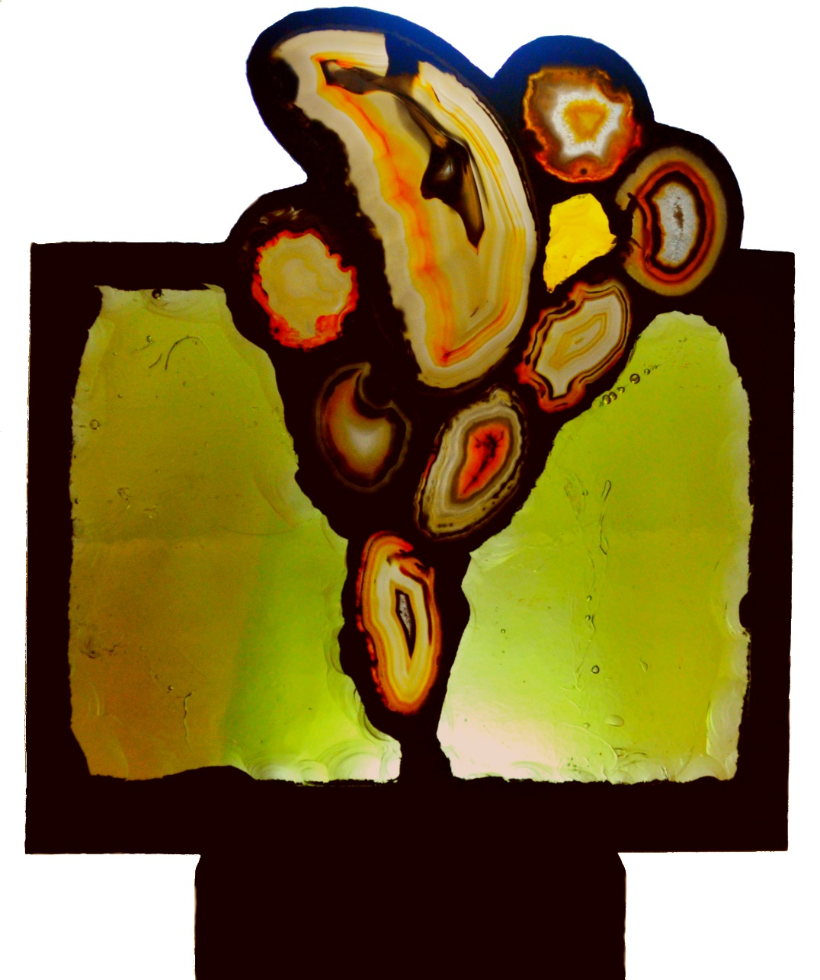
Lumière d’espoir /희망의 빛 No. II
Edition: Unique / 독특한
Materials: Agates and Slab glass / 마노와 스테인드 글라스
Signed by artist, certified by Artist
Year: 2016
Artist: Christophe Denoux (크리스토프 더누)

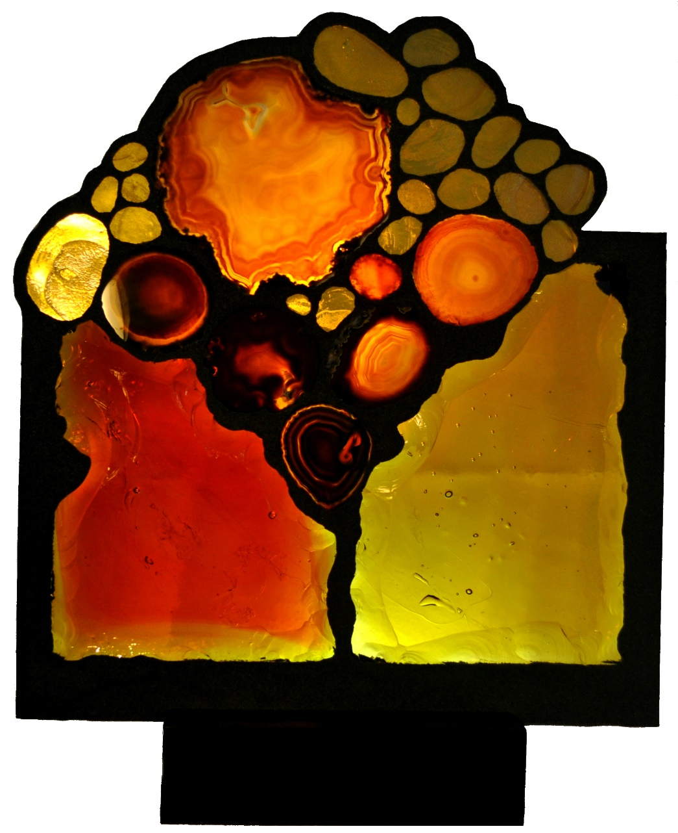
Lumière d’espoir / 희망의 빛 No. III
Edition: Unique /독특한
Materials: 100’s years Old Gold, Agates and Slab glass / 100 년 된 금, 마노와 스테인드 글라스
Signed by artist, certified by Artist
Year: 2016
Artist: Christophe Denoux (크리스토프 더누)

